Annual Sales Analysis Report

Business: **Moparts Auto Spare Parts**

Period Covered: January 1, 2024 – December 31, 2024

Prepared On: June 17, 2025

**📊 1.Summary**

This report presents a comprehensive analysis of sales performance for the 2024 calendar year. It highlights total sales figures, revenue distribution by product category, top-performing products and strategic insights for growth.

**💰 2. Key Sales Metrics**

|  |  |
| --- | --- |
| **Metric** | **Value** |
| Total Sales Revenue(year 2024) | KES 16,789,490 |
| Total Units Sold | 2,541 |
| Average sales(Monthly) | KES 1,399,124 |
| Highest Sales Month | July 2024 (KES 2,334,700) |
| Lowest Sales Month | January 2024 (KES 840,650) |

**📅 3. Monthly Sales Trend**

|  |  |
| --- | --- |
| MONTH | REVENUE |
| JANUARY | Ksh840,650 |
| FEBRUARY | Ksh1,255,710 |
| MARCH | Ksh1,245,000 |
| APRIL | Ksh1,105,840 |
| MAY | Ksh1,266,200 |
| JUNE | Ksh1,239,800 |
| JULY | Ksh2,334,700 |
| AUGUST | Ksh1,595,570 |
| SEPTEMBER | Ksh1,265,400 |
| OCTOBER | Ksh1,285,050 |
| NOVEMBER | Ksh1,736,620 |
| DECEMBER | Ksh1,618,950 |

|  |  |  |
| --- | --- | --- |
| Quarter | Total Revenue (Ksh) | Average/Month |
| Q1 (Jan–Mar) | **Ksh 3,341,360** | Ksh 1,113,787 |
| Q2 (Apr–Jun) | **Ksh 3,611,840** | Ksh 1,203,947 |
| Q3 (Jul–Sep) | **Ksh 5,195,670** | Ksh 1,731,890 |
| Q4 (Oct–Dec) | **Ksh 4,640,620** | Ksh 1,546,873 |

**🔍 Insights:**

* **Q3 was the strongest quarter**, largely driven by July’s high sales.
* Sales **steadily increased from Q1 to Q3**, then slightly dipped but remained strong in Q4

**Maximum Sales per Month**

|  |  |  |
| --- | --- | --- |
| MONTH | SPARE PART | AMOUNT |
| January | Front Axle Frr | KES 75,000 |
| February | Cabin Fvr | KES 100,000 |
| March | Diff Cxz | KES 80,000 |
| April | Front Axle Frr | KES 67,000 |
| May | Gear Fh | KES 70,000 |
| June | Front Axle Fh | KES 65,000 |
| July | Gear Frr | KES 170,000 |
| August | Cabin Ashock | KES 120,000 |
| September | Hangers Tata | KES 77,000 |
| October | Front Axle Frr | KES 58,000 |
| November | Cabin Fsr | KES 140,000 |
| December | Gear Fvm | KES 90,000 |

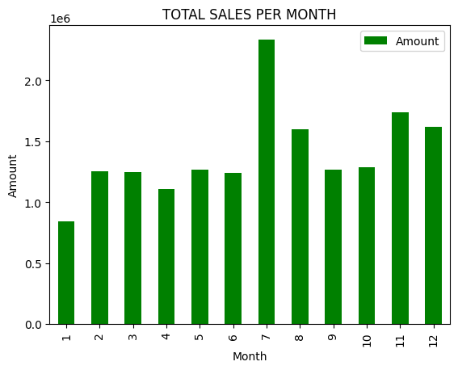

**🔝 4. Top-Selling Spare Parts by Revenue**

|  |  |
| --- | --- |
| Spare Part | Revenue |
| Diff TXD | KES 539,000 |
| Axle TXD | KES 390,500 |
| Front Axle FH | KES 370,000 |
| Front Axle FRR | KES 342,000 |
| Front Axle FVZ | KES 335,000 |
| Diff Fighter | KES 332,000 |
| Gear TXD | KES 263,000 |
| Gear FH | KES 233,500 |
| Gear TATA | KES 227,000 |
| Springs | KES 194,500 |

Insights:

* This represents products that generated the highest income.
* High-margin items like SPRINGS, PIPES and BOLTS contributed significantly to revenue despite moderate volumes.

**🔁 5. Most Frequently Sold Items**

|  |  |  |
| --- | --- | --- |
| Spare Part | Frequency | Revenue |
| Springs | 285 | KES 2,696,400 |
| Bolts | 95 | KES 98,350 |
| Pipes | 88 | KES 86,400 |
| Bearings | 54 | KES 291,100 |
| Rims | 46 | KES 387,600 |
| Axle txd | 32 | KES 487,700 |
| Hanger tata | 21 | KES 74,100 |
| Hanger txd | 21 | KES 71,900 |

Insight: These items are fast-moving and should always be well-stocked

**🧠 6.Best Selling Vehicle Brand**

|  |  |
| --- | --- |
| Vehicle Brand | Revenue |
| Txd | KES 3,418,000 |
| Fh | KES 2,137,500 |
| Frr | KES 1,475,900 |
| Cxz | KES 1,423,000 |
| Tata | KES 1,044,600 |
| Fighter | KES 768,500 |
| Fvz | KES 699,050 |
| Fuso | KES 605,600 |
| Igogo | KES 289,700 |
| Ashock Leyland | KES 184,400 |
| Toyota | KES 95,100 |

Insight: TXD emerged to be the best-selling vehicle brand despite the fact that it’s slowly getting out of the market

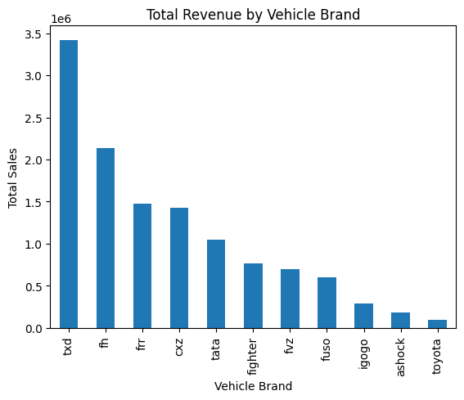

**🚀 7. Recommendations**

Inventory Management: Implement predictive restocking for high-frequency items.

Supplier Review: Negotiate better terms (prices) for top-selling parts to improve margins.

Book keeping: Ensure accurate sales records by capturing all the required information i.e. car brand, sales revenue and dates. This enhances accurate sales analysis results.

**8. Conclusion**

In conclusion, the sales analysis report highlights areas of strength and opportunities for improvement in Moparts Auto Spares Company's sales operations. By leveraging the insights provided in this report, the company can develop targeted strategies to drive revenue growth and achieve its business objectives.